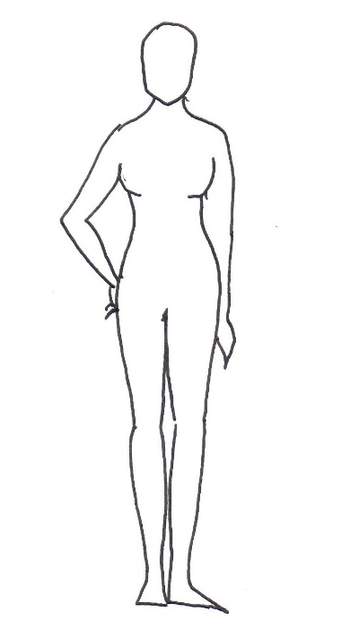
5
4
3
2
1
NAME

MOBILE NUMBER

EVENT DATE

COSTUME/S REQUIRED (send a name or screenshot)

1 | BUST
2 | UNDER BUST*
3 | WAIST**
4 | HIPS
5 | DROP***
6 | HEIGHT
7 | BICEP****
Please measure in inches only
(please do not measure in cm and convert, as this will be inaccurate)
* This measurement is needed for these garments as the waist seam will sit high on the ‘Empire line'.

** Please measure at the fullest part of the waist (typically across the bellybutton).

*** ‘Drop’ measurement, from under-the-bust line to floor (gives us ideal dress length).

**** Some dresses have a narrow sleeve opening, so we need to check arm circumference.

We do not judge what size our clients are: we simply want to ensure the best fit.
Please be accurate and honest with all measurements.

